Easington Parish Seats
A survey was carried out 24/06/2021, below are the results of that survey with the latest updates

Seat ID | Location | Previous Result/Comments | Updated 25/06/21 | Notes
01 | Westfield Lane halfway along lane | Requires new Wood & Painting | Not surveyed | Seat provided by Easington Amenities Org
02 | Westfield Lane, Hull Rd end | Recently Replaced | Useable No Further Action required | Seat provided by local families/individuals
03 | Dimlington Bungalows | Replaced by ERYC | Useable No Further Action required
04 | Baulk End (Jubilee Seat) | Requires new Wood & Painting | Unusable see Appendix 1
05 | Baulk End (Bus Shelter) Bench Style | Recently Installed | Useable No Further Action required
06 | Blacksmith’s Corner | Recently Installed | Useable No Further Action required | Seat provided by local families/individuals
07 | The Square (near Bus Stop1) Bench Style | Requires Painting | Useable requires painting
08 | The Square (near Bus Stop2) Bench Style | Requires Painting | Useable requires painting
09 | The Square (near Citizen-Link) | Recently Installed | Useable No Further Action required | Seat provided by local families/individuals
9a | Community Hall | NA | Useable No Further Action required | Easington in Bloom
10 | The Village Garden | Requires new Wood & Painting | Unusable see Appendix 2 and 2a | Seat provided by local children on Operation Lifestyle
11 | Humberside Lane | Recently Installed | Useable No Further Action required
12 | Cemetery (outside) Bench Style | Requires Painting | Useable requires painting
13 | Cemetery (inside) | Recently Installed | Useable No Further Action required | Seat provided by local families/individuals
14 | Cemetery (inside) | Recently Replaced | Useable No Further Action required | Seat provided by local families/individuals
15 | B.P. Footpath | Recently Repaired | Useable No Further Action required | Seat provided by Easington Amenities Org
16 | Cliff Top (Rocket Field) | Recently Installed | Useable No Further Action required
17 | Seaside Rd (Chapel) | Removed | N/A | Seat provided by local families/individuals
18 | Seaside Rd  Bench Style | Requires Painting | Useable requires painting
19 | Seaside Rd, Firthholme Rd corner | Requires Painting | Useable requires painting/repair see Appendix 3
20 | Seaside Road | Picnic Table replaced | Useable No Further Action required | Original Seat provided by Easington Amenities Org, replaced by Caravan Site
21 | Easington Rd Kilnsea (opp pond) | Recently Replaced | Useable No Further Action required
22 | Kilnsea Rd nr Church | Requires Painting | Useable requires painting
23 | Kilnsea Rd Blue Bell corner Bench Style | Requires Painting | Useable requires painting

Appendix 1
Bench 4 Jubilee Seat at Baulk End – This bench is in serious disrepair and is unusable (see pic 1). Due to the area in which the seat is situated (see pic 2) We would suggest (considering recent public allegations of lack of public consultancy) that public opinion is sought on whether the seat is replaced or removed 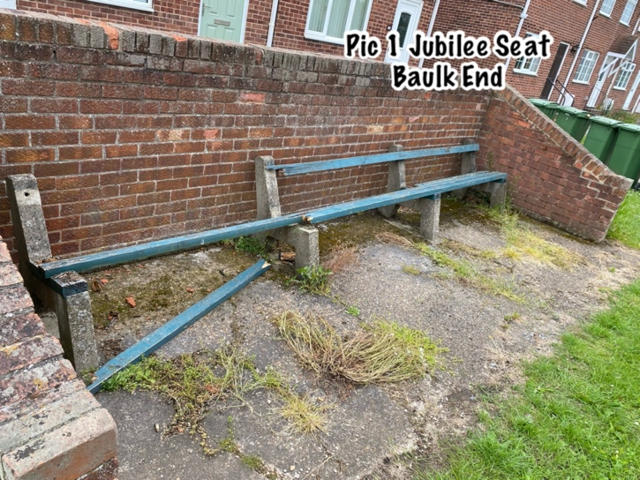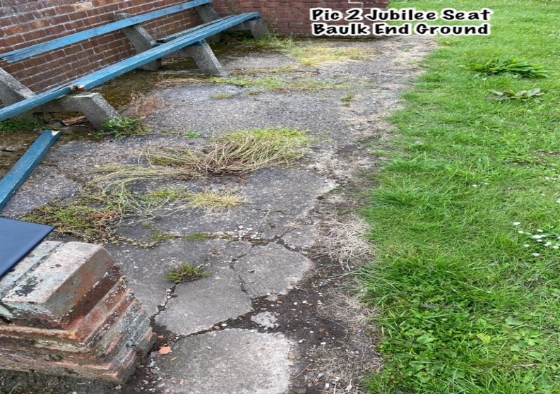

Appendix 2
The seat within the Village Garden is also in serious disrepair and unusable. Again, and considering this seat was provided by local children that took part in Operation Lifestyle, we believe for the reasons in Appendix 1 that public consultation be sort of its repair/removal.
We would also like to note 2 further points regarding the Village Garden
- Many residents (especially new to the village) are unaware that the Village Garden exists – should we try and raise the profile of this village asset? (Possibly replace the bench with a Picnic Bench?)
- Upon walking in the Village Garden, we notice 2 potential obstructions that could cause injury especially to young children (see pics below) and would request further discussion by the PC as to whether these would cause any PC liability should an accident occur?

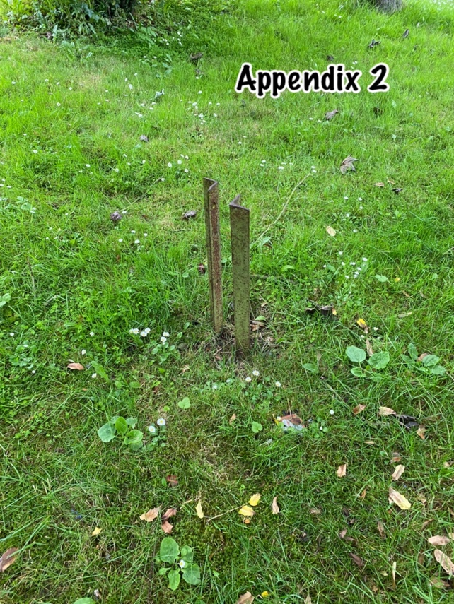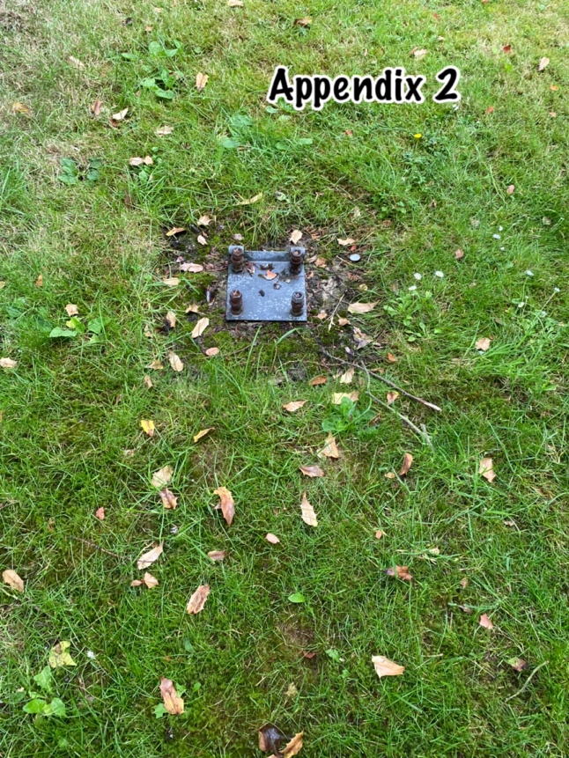

Cllrs Myers & Wilson 25/06/21

